ASSOCIATIVE DISTRIBUTED MEMORY MODELS OF NEURAL NETWORKS
Tanyu Kolev SNC „Sub Specie Aeternitatis - 2011"
Recently, thanks to numerous theoretical and experimental discoveries in the physics of the spin-glass state, a rather coherent and aesthetically attractive overall picture has begun to emerge.
V.S. Dotsenko, Dissertation Abstract
Based on the idea of ​​the immortality of genes lies the nature of the memory of DNA molecules, which is realized through the replication process. The idea of ​​technological personal immortality is based on another idea - associative distributed memory of neural networks. Associative psychology is one of the oldest and most fundamental directions in psychology, which arose in antiquity and has a rich history that deserves special attention. Associationism explains the functioning of the psyche through the principle of associations - the connections between ideas, representations, sensations, perceptions or feelings. In the 40s and 50s of the 20th century, Carl Lashley conducted a series of experiments on removing the cerebral cortex of experimental animals, which had unexpected and significant results. The surprise came from the finding that the deterioration of its memorization was proportional to the magnitude of the mass of the damaged cortex, but did not depend on the location of the lesion. Memory is realized in a distributed form, as a collective structure in the brain. Since Lashley's time, research related to the search for memory engrams has come a long way, but the titles of articles and reviews are still like this: "Still looking for the engram". This is how the idea of ​​​​the memory of the nervous system arises, which we call associative distributed memory.
Over the past decades, scientific research has made enormous progress in understanding associative distributed memory. The theory of this memory is in the form of models that complement each other. The proposal of models of associative distributed memory has primarily affected the development of the field of artificial intelligence. But the importance of these models does not end there, it is fundamental for the understanding of the psyche and consciousness. The process of assimilating models from psychology is still ahead and I assume that this process will have revolutionary significance for psychological science.
The integration of associative distributed memory models into psychological science can be achieved through an appropriate methodological tool. Direct synthesis is much more difficult and slower. The most appropriate and constructive methodological tool for synthesis is the concept "systems of information" proposed in the 1970s. Moreover, the author of the concept takes the next step and tries to develop certain views on the psyche precisely as the system of information, without having any idea what significant knowledge will be achieved in the next few decades.
Here I will consider three indicative models of associative-distributed memory, which complement each other and are subject to synthesis through the eyes of the methodological concept of "information system". The entire article should be considered as a necessary introduction to the application of this synthesis to the problem of the spontaneous emergence of the psychic subject in neural structures. The solution to this problem is a solution to the psychophysiological problem, which is a node for technological personal immortality. After solving this problem, a theory of psychic processes can be developed, which would include self-consciousness, emotions, attention, thinking, subconscious psychic, etc. Consciousness, which in its mode of existence is not distinguished from the psyche, can be interpreted as a quality of a certain system of information.
1. Holographic model of neurological memory.
Karl N. Pribram (1919-2015) is the author of the first attempt to propose a model of neurological memory based on an analogy with the physical process of holography. This is the first theoretical model of memory that successfully interprets both its distributed nature and the property of associativity - addressing by content, restoring an image by parts of it. The neuroholographic model has developed over the years and has not lost its relevance as a source of heuristics and direct visualization of processes.
Holography is an analogue of photography, but in it a trace is left on the storage medium (photographic plate, crystal, etc.) that carries all the information about the wave front coming from the photographed object - amplitude and phase of the wave. Under certain conditions, the wave front can be restored in its entirety and not differ in anything from the original.
How is information encoded in holograms? When the wave front coming from the captured object meets the reference beam, interference occurs. This interference pattern is fixed on some medium. At first glance, its appearance has nothing to do with the captured object, but in reality, all the information about the wave front coming from the object is fixed on the medium. Hence the name “holo-”, i.e. complete fixation of both the amplitude and the phase of the wave. M. Arbib uses the apt expression – “holograms are frozen waves”. It is enough to direct a restoring reference beam, analogous to the one with which the fixation was made, at the hologram, then it will play the role of a diffraction grating, and the diffraction will cause an absolutely identical wave front with which the storage medium is affected. A three-dimensional image appears, identical to the captured object. The information stored on the hologram is in a distributed form – each section of the hologram carries the complete information about the object. If we break the hologram into pieces, each of them can be used to reconstruct the image! The quality of the image deteriorates if the piece of the hologram is too small, but each piece carries all the information and this is very reminiscent of the results of K.S. Lashley.
Here is an interesting diagram that illustrates the associative properties of the hologram:

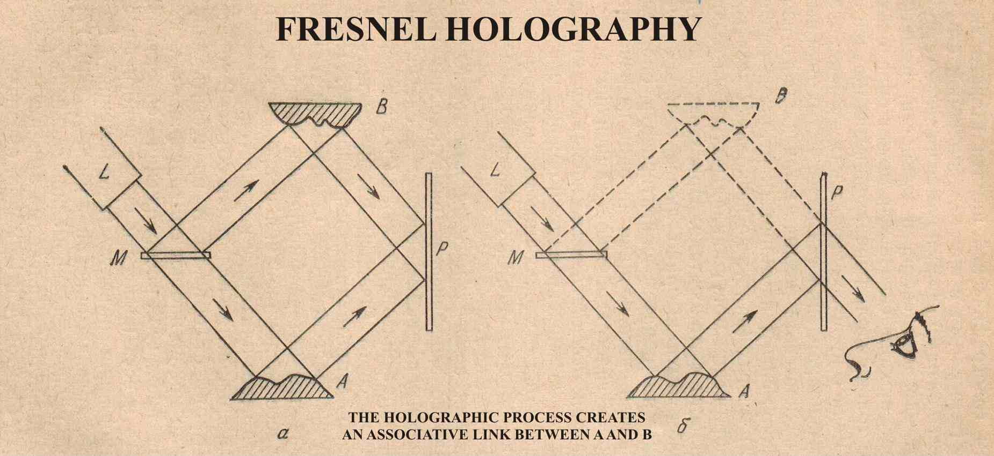
Fig.№1.
(The scheme is borrowed from T. Kohonen without changes)
If the hologram stores the wavefronts coming from two objects, labeled A and B, each serving as a reference beam for the other, then illuminating the hologram with the beam from object A can serve to reconstruct the image of B and vice versa - a demonstration of associative memory.
The similarity between the properties of neurological memory and the properties of holograms has been emphasized by a number of authors and discussed many times. Perhaps it is best to show this similarity in the form of a table:

Properties of the optical hologram | Properties of neurophysiological memory.
1. Distribution of the record. | 1. Lashley's law:  a/ insignificance of the site of cortical lesion  b/ dependence on the mass of the affected brain tissue
2. Image recognition: invariant, relative to size and movement. | 2. Image recognition as  something unified and complete;
3. Associativity. | 3. Associativity.
4. Volume, color and reproduction of movement in image restoration. | 4. Stereo perception, color, restoration of movement.

Fig. №2.
The similarity makes plausible the hypothesis that waves of neuronal activity can flow in the brain, which can be memorized (and later restored) in the form of neuroholograms. M. Arbib emphasizes that this is still only a holographic metaphor, very useful in attempts to understand how our nervous system works, how the psyche and the mental image arise. But others: K. Pribram; F. Westlake; S.N. Brynes and A.I. Suslov, etc., believe that neuroholograms really exist, as the neuroholographic process will not be the same substrate as in ordinary holograms. The methodological effectiveness of the model is demonstrated by the publications that continue to this day. Most authors in this direction, from K. Pribram to N.S. Brynes and modern authors, all of them devote a lot of space to justifying the neuroholographic process in the nervous system, the presence of coherence in the impulse activity of neurons. But they all underestimate one well-known feature – holography became a technology and began to be used after the appearance of suitable lasers! The coherence of the electromagnetic wave, which is used to create a hologram and to manifest the stored content, is extremely important, and it is achieved separately and in an independent device – the laser. Obviously, something is missing from the holographic metaphor to explain all the registered properties of memory and the psychic growing on it, but this does not reduce its heuristic value.
The process of creating a holographic trace on a certain material, even in its most primitive simplified implementation, without making the hypothesis of the presence of a neuroholographic process, demonstrates something unique and very indicative. The two wavefronts from object A and object B, from the above scheme of T. Kohonen, interact and form an associative connection. Under certain circumstances, this interaction can grow into an mutual cooperation(!) and a system can arise. The interaction that is realized at the physical level of the signals is their interference. But light waves have some modulation (see T. Kohonen's scheme!) and the interaction passes to a new level. The modulation, i.e. the diversity carried by the signal, also has its content. In the process of holographic memorization, it is clearly seen how the physical interaction between the waves turns into an interaction at the level of the content of the modulation. A unique process of interaction between portions of diversity takes place, but this interaction is not only physical, but also in content, i.e. as information in the true sense.
Such a process becomes possible only if a coherent laser beam is used!
Laser radiation is the first example of a system that has undergone a non-equilibrium phase transition - self-organization of photons. Hermann Haken started precisely from the analogy between the behavior of the laser at the threshold of laser beam generation and phase transitions to substantiate the idea of ​​a new science - the theory of self-organization (synergetics). The laser beam can be considered as a system of photons that have undergone a non-equilibrium phase transition as a result of energy pumping and the inverse population of the emitting medium, which exceed certain critical values, i.e. it is a condensate of photons! The achieved coherence of photons as a result of the non-equilibrium phase transition is in fact the necessary coherence, without which holography is impossible. And together with coherence, a new level of interaction arises, where the content of the flow of diversity is decisive. The disadvantage of the holographic model of memory is precisely this: the main condition for self-organization - the non-equilibrium phase transition - takes place not in the memory medium, but outside it. But the holographic metaphor, even with this disadvantage, quite definitely shows that another type of systems can exist - systems of information, in the proper sense of the word! Even the elementary act of forming a trace in optical holography is very indicative of the process of emergence of systems of information! It directly suggests that such systems have a place and should be studied. The "seed crystal" for the emergence of a system of information is well outlined.
When the hologram is used as a filter and performs recognition of certain images, it is obvious that what is recorded on the filter will be recognized. A text is recorded in which all letters are included, but we want to recognize the letter E and we use a suitable hologram on which the letter E is recorded. It is this hologram that is used as an effective filter for recognizing the letter E. In all places where the letter E is present in the text, a luminous spot will appear. The hyperstructure (information) of the text interacts with the hyperstructure (information) recorded on the hologram.
As a result, we get recognition of a certain image, the letter E!
Here the question arises:
“Who recognizes the image – the hologram itself, as a physical object, or the recording of the hologram!?”
The answer is more than clear: Not the hologram as a physical object, but the recording on it, the information is decisive in the recognition process. From what record is fixed on the hologram we will be able to recognize one or another image! The hologram, as a physical object, is only the general condition for such a process, and its specific implementation depends on the specific information recorded on the hologram.
Yes, ... but then, why when we consider another process of image recognition, which is implemented by natural or artificial neural networks, by certain brain structures, do we say that the neural network recognizes or that the brain structure recognizes!?
No, it does not recognize the neural network, it does not recognize the brain structure, but
the information previously recorded on it. It is precisely appropriately organized and structured information that performs the recognition!
Therefore, although the brain or neural network is the material carrier on which researchers persistently focus their attention, there is a “subtler” matter that exists as a hyperstructure in the main physicochemical carrier. It is this hyperstructure that is the immediate carrier of information. Image recognition and all other interesting manifestations, such as mental processes, projection, consciousness, etc. are properties of this information system, i.e. of memory, as a system of information. This is a new qualitative level - a system within a system (according to the expression of V.I. Kremyansky!) and it is it that is the bearer of all these interesting and unique properties.
Holographic interference and diffraction were the first to show that electromagnetic signals can interact in such a way that their content becomes the leading one, and not so much their physical nature and substrate. For a functional information system to arise in its own sense, which would operate with subjective reality and make management decisions about behavior, the question of the interaction of signals by content is of fundamental importance! But the holographic model of memory is not capable of giving answers to these questions, but it suggests...pushes the imagination and motivates the search for new models.
2. Kohonen's System Model for Associative Memory.
Teuvo Kalevi Kohonen (1934 – 2021) is the first president of the European Neural Network Society. He first proposed a systemic theory of associative memory in the remarkable monograph “Associative Memory, a System-Theoretical Approach”.
The associative property of mental memory is clearly visible under the phenomenological surface (L.M. Wekker) of the phenomenon. Associativity has been the subject of attention since ancient times and was later presented and studied within the framework of the psychological concepts of associativeism. However, it was not until 1978 that Kohonen in the cited monograph proposed a theory of associative memory implemented in the concepts of the system-information paradigm with sufficient specificity and rigor and a corresponding mathematical apparatus. Kohonen gives a general model of associative memory, which works equally well in two directions: first, as an «elementary cell» for understanding the phenomenon; second, as an opportunity to build and understand significantly more complex associative processes and their dynamics. If the concept of «Turing machine» is a way to understand universal computation and algorithm, then Kohonen's scheme of associative memory is a concept of the same rank, which is a way to understand associative memory and thus - an associative system of information. Revealing the connection with the concept of «collective computation» outlines the qualitative difference with the concept of «algorithm».
Kohonen's scheme can be presented as follows:
There are four information channels to the memory.
The first three are input, through which information is entered simultaneously in the form of some images and one output, through which information is selected. Associative memory is a device from which recorded data (a group of images connected in some way) can be reproduced, using any of the recorded elements as a selection criterion.
It is assumed that at the input of the associative memory an image K(t) is generated, where t is the time parameter.
The second channel is fed with an image C(t), which is connected to K(t) and can be considered as a feature.
At the output at time t, an image R(t) is formed, which, using feedback with a time delay Δ on a third channel at the input, an image
R (t – Δ), (similar to K(t)) is formed.
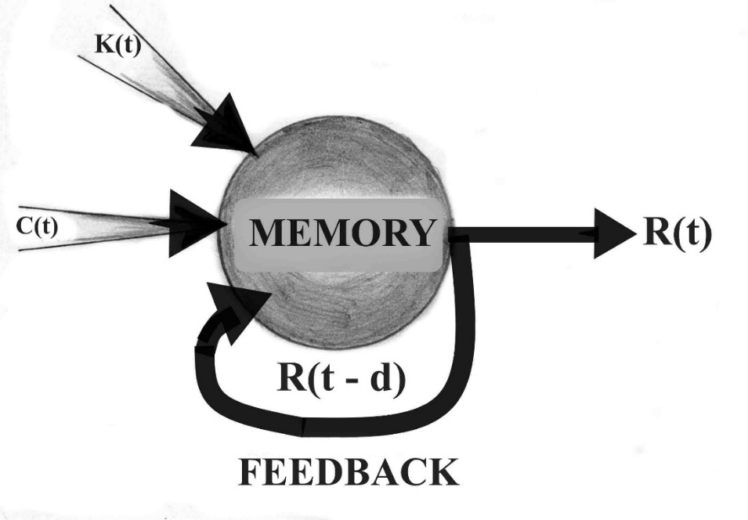
Fig.№3.
Each new triple appearing at the input is recorded in memory. This scheme can be used to record structured knowledge and be generalized to the case of continuous time and asynchronous mode.
The triple [ K(t), C(t), R( t – Δ )] can be considered as a single static image for a certain moment of time t and it can be recorded in memory. T. Kohonen interprets relations as associations and vice versa, because each association represents a two-element relation that contains three symbols, one specifies the name of the relation, and the other two – its arguments.

(A, O, V) A
O → V

With the following reservations:
- A is a relation, but it is not just a relation, because all elements of the triple are preserved together and there can also be cross-relations, which are again associations;
- The simplest way to avoid misunderstandings is to call the entire structure associative memory, but the nature of the process by which the association between elements is carried out, its physical meaning, will bring additional clarity to the system.
Recording stage:
It is assumed that at the input of the associative memory the images K(t) and C(t) are sequentially generated, while at the output an image R(t) is simultaneously formed, comparable to K(t). Then, with a delay Δ, an image R( t – Δ ) is formed at the input. Each new triplet at the input is recorded in the memory. (There are associative memories in which the images accumulate in the storage medium in a spatially distributed form, without interfering with each other and creating noise, causing changes, as a collective effect. This is the case that is of greatest interest!)
Access to the necessary information recorded in the memory is realized using the attribute C(t), and the termination of the recording process occurs when an “empty” image appears in the sequence of images, which cannot be memorized.
Reading stage:
The associative search process begins when the input is given an image K and the context information C associated with it. Then the primary feature K can be excluded from consideration, but the context information C must remain.
As a result, the output image R = K is obtained. The retained output signal R( t – Δ ) and C , i.e. the pair (C,R) are transformed into a new key-feature, which leads to the next image R(t). In this way, all previously recorded information is traversed, together with the context image. The sequence of images is interrupted when an empty image is output. T. Kohonen emphasizes that the form of representation of relations in associative memory using triples is the simplest construction, on the basis of which structures of arbitrary complexity can be built. Therefore, this model of associative memory can be considered the simplest. Significantly more complex models are possible!
The model of associative memory thus presented is not a one-time act, but rather a cyclical process or “vortex” that involves a certain group of images in some temporal sequence.
T. Kohonen’s model is of fundamental importance for understanding associative memory and for interpreting significantly more complex models, and at the same time for understanding the concept of a system of information as applied to the psyche, consciousness and self-consciousness. If physical systems are built of elementary particles, atoms and molecules, then the “building block” of the psyche as a system of information is precisely this simplest model of associative memory. The true power of this abstraction becomes apparent when it is applied to perhaps the most amazing discovery of physics in recent decades – the “spin-glass” phase. The processes in the spin-glass and its memory, i.e. The possibility of these physical laws serving to create a model of the processes in neural networks, and with it of mental memory and mental processes, is a truly amazing discovery that has not yet been adequately appreciated.
The "spin-glass" models of the functioning of neural networks for the first time in the history of science allow us to outline very specific and convincing steps for a complete overcoming of the psycho-physiological paradox and building a theory of the psyche not from the point of view of subjective experiences, but from a natural scientific (ontological) point of view. The information processes revealed by the "spin-glass" models are in full agreement with Kohonen's model of the elementary cell of associative memory. The two models in synthesis reveal completely new aspects of the interaction of information in associative memory.
3. Hopfield's model of associative memory of neural networks.
3.1. The spin-glass phase.
The experimental and theoretical development of the issue of the so-called “spin glass” led to the realization that this area of ​​physics very well describes and explains the most essential properties of neurological memory. What is more, the spin glass theory has become a convenient bridge for transitioning through the neural networks - psyche section. It is not just about creating effective and working models and experimenting with them through computer programs on a universal computer, but about realizing a serious conceptual step in understanding the psyche. “Unsolvable” optimization and pattern recognition tasks have been successfully solved, which in the recent past were beyond the capabilities of computers. But this result is only the beginning and the least that is happening, because it is not about a more complex algorithm, it is not about a hardware expansion of computers, but about a deeper understanding of the processes of information processing in neural networks and their reproduction. It turned out to be possible to implement such information processes in artificial neural networks - electronic, optoelectronic and purely optical, built from neuromorphic elements, which demonstrate significantly higher efficiency. This path of research is more difficult, but it demonstrates the real possibilities of theoretical ideas in the field of "spin-glass".
The word “spin glass” is a metaphorical expression that means that the spin order in the material in question is very similar to the order of atoms in the formation of ordinary glass. Spin glasses are magnetic materials with unusual magnetic properties. The name “spin glass” appeared in 1968 and is due to the fact that the collective behavior of the magnetic moments (spins) is disordered and forms a kind of “glass” of the spins of different atoms.
Spin glasses are a fairly broad class of solids that include: metallic spin glasses - a mixture of Au1-x Fex , non-metallic, such as Eux Sr1-x S, or amorphous metal, such as Gdx Al1-n, and the concentration of the magnetic material can vary widely. This means that the presence of few factors is necessary for the material to exhibit the property of a spin glass. A common property of spin glasses is the presence of disorder and competition in the various magnetic interactions. This leads to a very complex structure of the phase space of the system and a large number of metastable states with slow relaxation processes, which is a prerequisite for the presence of memory.
What are the specific properties of the "spin glass" that are of interest?
In various "spin glass" materials, if the temperature drops below some critical temperature Tc, the magnetic moments freeze in random directions. The random directions arise due to the competition of magnetic interactions with different signs - one seeks to orient the spins parallel (ferromagnetic), the other - antiparallel (diamagnetic). In a disordered system, it is impossible to arrange all the spins in such a way that they satisfy all the magnetic interactions. A phenomenon arises that is called "frustration" and it is with it that many of the unique properties of this type of systems are associated.
The short explanation of frustration: We denote the spin-spin interaction by Jij, where i and j = 1, 2 ...N, where the number N is the number of spins in the system. Jij is random and the spins are fixed at some temperature. The following situation is possible: three spins J12, J23 and J13 interact, equal in magnitude, but can have different signs.
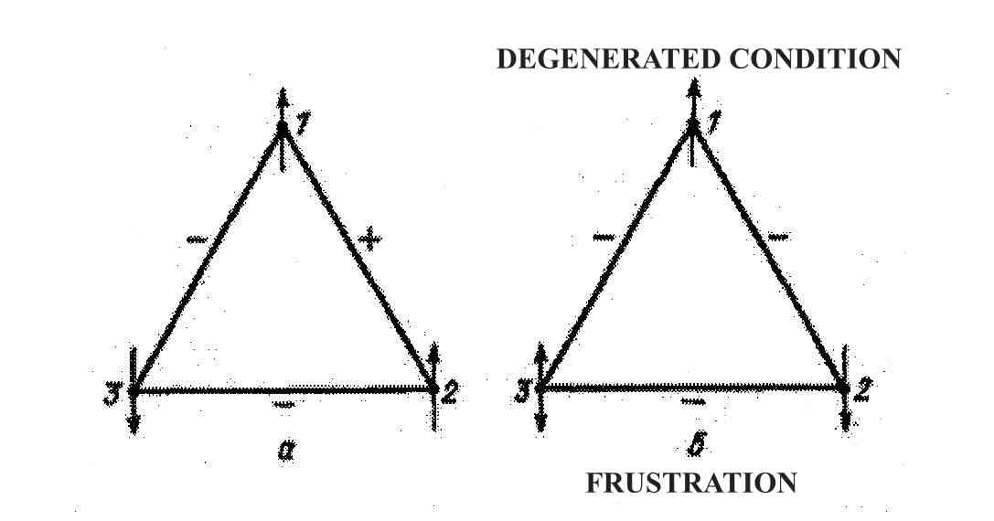
Fig. №4.

If the product of the interaction along the triangle is positive, this is case a/ the spins are consistent and the ground state of the system is not degenerate. But the interaction can be negative (case b/), the spins are not consistent. Spin 3 must be simultaneously oriented down and up, then the ground state of the system is called degenerate. But in a multispin system, the number N is very large, it is determined by the number of building particles with spin - atoms. The number of such triangles of incoherent spins successfully competes with the number of building particles. The consequence is an equally large number of frustrations! But a strongly frustrated material leads to a colossal degeneracy of the energy of the ground state. In the system there are a huge number of low-energy states. A number comparable to the number of atoms, of local energy minima – potential wells and with an energy close to that of the ground state. It is these states that make a significant contribution to the thermodynamics of the system at low temperatures.
The most significant difference between spin glass and ordinary ferromagnets or diamagnets is that in ferromagnets or diamagnets there are two possible states. These are spin-up or spin-down and the existence of long-range order in the substance, a manifestation of magnetism. In spin glass, the possible spin states are infinitely many and there is no long-range order. These states are relatively stable (metastable) and each spin is directed as dictated by its immediate environment, and the energy of the system is higher than the equilibrium one. Over time, such a metastable state very slowly relaxes to the thermodynamic equilibrium state, like any thermodynamic system. The most interesting experimental result is that at a temperature below the freezing point Tc, the magnetic susceptibility of the material cooled in a magnetic field differs from the susceptibility of the material cooled without a field. The magnetization depends on the prehistory of the sample. In addition, there is a residual magnetization, which after removing the external field very slowly drops to zero, i.e. the material has the ability to retain traces of impacts. A prerequisite for memory!
The magnetization is irreversible and depends on the time t , the temperature T, the applied magnetic field and the history of the sample - cooled with or without an external field. A fundamentally new low-temperature state with a clearly pronounced non-ergodicity has been discovered.
The simplified theory of processes takes into account, first of all, the disorder in combination with the competing magnetic interactions, as the energy of the system according to the Edwards – Anderson model ( EA) is equal to:
Where: Si = ± 1 the spin variable, numbered with index i ;
h – the external magnetic field; Jij – the random magnetic interaction. For Jij, a Gaussian distribution of the type:
P(J) = exp
The competition is ensured by the change of sign. If we assume Jij with a finite radius of action, for example, interaction with the nearest neighbors, no analytical solution has been found for this case. The numerical experiments conducted show that it has similar characteristic properties as the one with an infinite radius of interaction between the spins. The development of statistical physics has shown that many of the problems posed in it have an exact solution if an infinite radius of interaction is assumed. This theory is the so-called mean field theory (MFT). In the MFT limit, cooperative phenomena in the system are described qualitatively and accurately. This was also done for the Edwards–Anderson model, as , for N (where N is the number of particles). The result, without analytical derivation, is that at a critical temperature, for T Tc the phase space has a very complex structure. The free energy F as a function of the coordinates in the N-dimensional space of configurations, for T = 0 and E = H has a huge number of minima . The local minima of F ({ mi }) are in fact the possible realizations of the physical state of the system. While in ferromagnets there are two possible minima: M or - M , in spin glasses there are infinitely many local minima (the number is so large that the expression infinite can be admitted) and as many metastable states that slowly relax. When the temperature decreases in the ferromagnet, a phase transition occurs, the spontaneous magnetization of the material appears. A phase transition also occurs in spin glass, but what exactly and how exactly is a much more complicated task.
On this occasion, V.S. Dotsenko writes:
“First of all, the symmetry that is broken is directly related to the randomly frozen disorder. But the main thing is that, unlike “normal” magnets, here the phase transition occurs not at a critical temperature Tc, but at an arbitrary temperature lower than Tc. In other words, at a temperature lower than Tc, a continuous cascade of phase transitions occurs, ergodicity is broken, and accordingly the free energy appears non-analytical at an arbitrary temperature lower than Tc.”
A unique property has been formulated – a continuous cascade of phase transitions at any minimal change in temperature – Δ T. In the ordinary phase transition from the paramagnetic state to the ferromagnetic state at a temperature lower than a certain critical temperature Tc, a spontaneous symmetry breaking occurs and the system takes one of two possible states:
〈σ_i 〉 = - m or 〈σ_i 〉 = + m
〈σ_i 〉 - is the average magnetization, m – is an order parameter that becomes zero when the temperature increases to the critical one. Between these two “valleys” in the state space of the macroscopic system there is an infinite barrier of free energy and therefore after lowering the temperature below Tc and the system finds itself in one of these valleys, it cannot go to the other “valley” for any finite time. With a continued decrease in temperature, no other spontaneous symmetry breaking occurs in an ordinary ferromagnet. In spin glass, there is also a critical temperature Tc, above which it exists in a paramagnetic state. When the temperature is lowered below Tc, a phase transition also occurs, but the phase space is no longer divided into two “valleys” as in ferromagnetism, but into many “valleys” (for a macroscopic system, these “valleys” are infinitely many), separated by infinitely large free energy barriers. As soon as the temperature drops below Tc , at
T = Tc – δT, (given that the process is continuous!)
each “valley” is characterized by non-zero thermodynamic averages 〈σ_i 〉_α, where α is the “valley” number and the average value is obtained for this valley α. Only these thermodynamic averages “inside the valley” have physical meaning. The physical order parameter:
describing the degree of "freezing" of the spins, for each "valley" turns out to be the same as for all other valleys, as at T → Tс, q → 0. With a further decrease in temperature by δТ, a new phase transition occurs in each valley, the local symmetry and ergodicity for the "valley" are broken, and each "valley" breaks up or breaks into many more new "valleys". And these valleys, as already noted, are infinite for a macroscopic system. Each is also separated by an infinite barrier of free energy from the others. Each valley is characterized by its own order parameter, which increases in value as the temperature drops. This process continues tightly and continuously until the temperature reaches absolute zero. This means that the spin-glass system, when the temperature drops below the critical temperature, is continuously in a non-equilibrium phase transition!
And one more detail, at a temperature lower than the critical one, inside each "valley", there are infinitely many metastable states, separated by finite energy barriers. Inside the "valley" there are barriers of very different values ​​and extend to infinity, which leads to the fact that in fact thermodynamic equilibrium in each of the "valleys" can never be reached for any finite time.
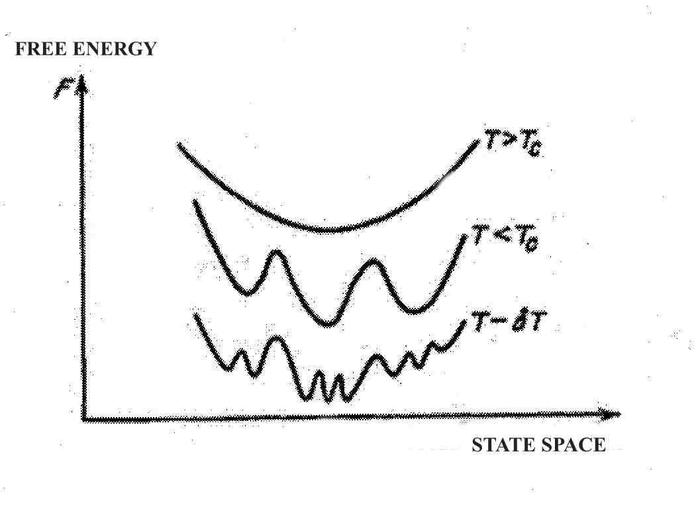
Fig. №5.
The behavior of the free energy relief with decreasing temperature!
Naturally, the question arises – how to determine the order parameter that would reflect the phase transition of the spin glass!?
The order parameter introduced above is for a specific “valley” and does not contain any information about the other “valleys” or their location in the phase space. But what a trick the authors working in the field have come up with!
It is assumed that a series of thought experiments are being conducted. At a certain temperature lower than the critical one, starting each time from a new spin state, we will let the system relax as close as possible to the equilibrium state. In each such experiment, the system will “get stuck” somewhere and the average magnetization will be , where α will denote the experiment number. The states of the different “valleys” will differ and will be a huge number, moreover, the “equilibrium state” in this case is very conditional, since an equilibrium state in the “valleys” never occurs, and in fact it is assumed that the magnetization is quite quickly established at a certain numerical value. Let's conduct as many such experiments as possible! Then let's introduce a quantity that describes the overlap (or the degree of similarity) of the states in the different experiments:
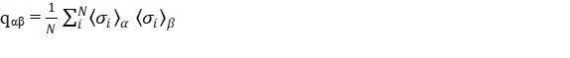
As obviously qαβ ≤ 1, due to diversity, and the maximum value 1 will be reached when the results of experiment α and experiment β coincide. If there is no similarity and correlation qαβ = 0; The parameter qαβ can serve as a kind of metric in the state space and the inverse of it 1/qαβ can be called the “distance” in the state space:
Now, to describe all possible overlaps between all states ("valleys") existing at a certain temperature, it is convenient to introduce a distribution function of the values ​​of qαβ. Formally:
P(q) = $\sum_{α,β}{δ(q_{α,β}}$ – q)
It should be borne in mind that the delta function is not zero strictly at a point, but some small finite interval Δq , the overlap will be for the interval from q to q + Δq. It can be said that the distribution function P(q) is that physical parameter that essentially distinguishes spin glass from other more ordinary materials. The possible types of functions P(q) are shown in the figure below:
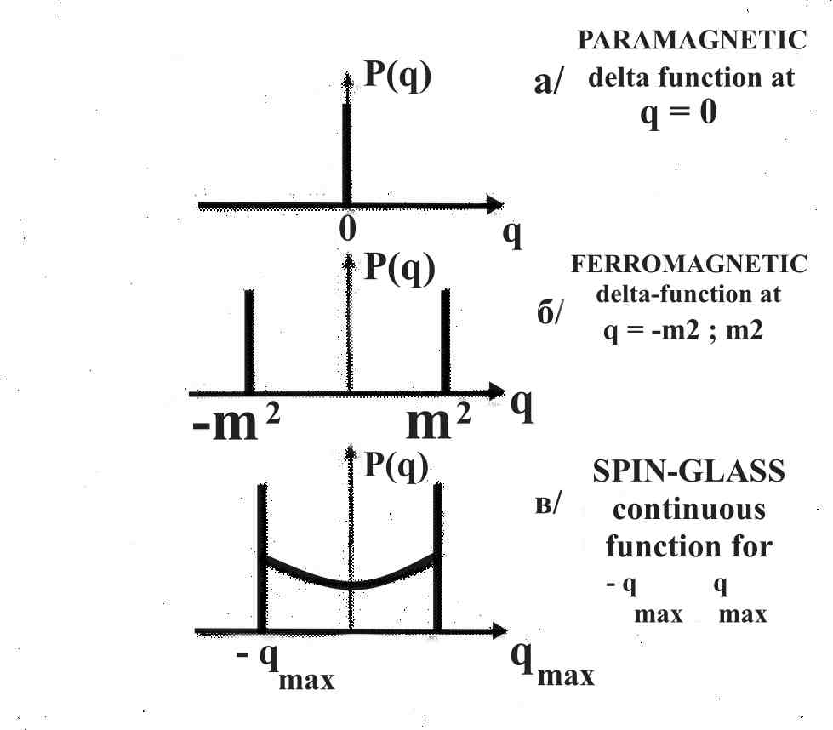
Fig.№6.
The distribution function P(q): a/ for a paramagnetic phase; b/ for a ferromagnetic phase; c/ for the spin-glass phase.
The possible types of functions P(q) are shown. a/ depicts the state of a paramagnet, zero magnetization depicted as a δ-function at q = 0 ; b/ this is a ferromagnet at a temperature lower than the critical Tc with two states of magnetization of the nodes ±m , therefore P(q) represents two δ-functions at q = +m2 and q = - m2 . In a categorically different way, P(q) looks like in the case of a spin glass, this is the case c/ between the δ-functions at q = ± qmax(T) there is a continuous smooth function. The quantity qmax(T) is the maximum possible value q_αβ , which is equal to the “self-coincidence” that characterizes each individual “valley”. The existence of a continuous function in the interval ( 0, ± qmax(T)) is associated with the continuous fragmentation of each newly emerged "valley" into even smaller ones, and since they arise in a hierarchical order, the states inside each valley cannot but have some overlap and correlation.
The next step in this logical process is the introduction of a more complex function of overlapping three states, which are: q1 , q2 , q3:
It turns out that for a long-range spin glass, i.e. mean field theory, this function can be calculated analytically and the result is amazing. P(q1,q2,q3) is not equal to zero when two of three overlaps are equal to each other and do not exceed the third in magnitude:
q1= q2 ≤ q3 or q1 = q3 ≤ q2 or q3 = q2 ≤ q1
In all other cases P(q1,q2,q3) is identically equal to zero!
This result is very indicative – in the space of states of a spin glass there are no triangles with different sides, all triangles are either isosceles or equilateral! A space with such a metric is called ultrametric!
In mathematics, such spaces have been considered since the late nineteenth century, and in physics they first appeared with the study of spin glasses. An ultrametric space is best illustrated using a hierarchical tree:
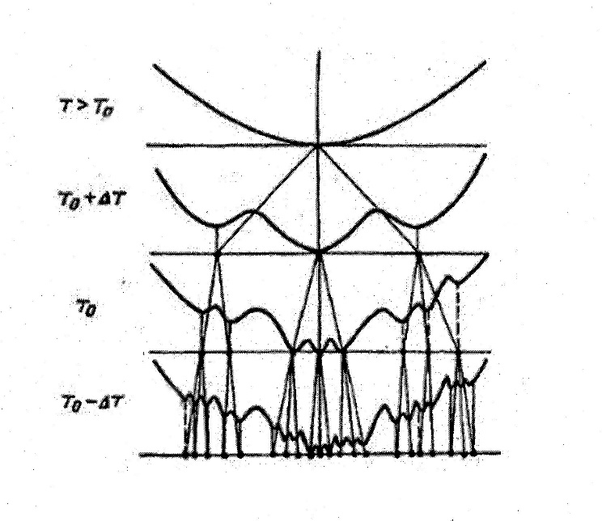
Fig.№7.
Hierarchical tree of the spin glass state space.
The state space of the spin glass is the set of endpoints of the hierarchical tree depicted in the figure. The metric in this space is determined by the fact that the overlap (i.e., the distance) between two states depends only on the number of generations to the nearest common “ancestor”, since with an increase in the number of generations, the amount of overlap decreases. The described ultrametric metric is automatically implemented in such a space.
The exposition of the main properties of the “spin glass” here is rather dry and focused only on the final results. The new physics of disordered systems needs a much more complete and emotionally saturated story. Is there a physicist who would not be shocked by these results!?
Something truly unusual occurs in the spin glass – a phase transition for any change in temperature lower than the critical temperature Tc. For every change ΔT, if it occurs at a temperature lower than the critical Tc, a phase transition occurs, no matter how small Δ is. Infinite phase transitions and infinite fractal splitting of the free energy curve. Probably, physics will discover other physical systems with similar unique and stunning behavior in the future, because the “spin glass” turns out to be a sufficiently general model. Scientific knowledge has only recently managed to find ways to describe and study such systems, and this opens the way to understanding the activity of the nervous system.
3.2. A “spin-glass” model for the associative distributed memory of neural networks.
When John Hopfield's article appeared on the application of these results to the description and understanding of the associative distributed memory of neural networks and the unique information processes taking place, I expected an explosion in psychology and neuroscience, but the explosion took place only in the field of artificial intelligence. Obviously, this physics turned out to be difficult to access for psychologists, neurobiologists and philosophers, and for this very reason it must be spoken and narrated in an accessible way. It is not only about new physics, but about such a new physics that can be directly applied to a materialistic solution of the psycho-physiological problem. And not only that, but also about a completely new look at the computational process (not so "digital" at all!), at the evolutionary process and the order in the world. I was so strongly impressed by the possibilities that were revealed, as logical extensions, that later I was not at all surprised when the Nobel Prize in Physics was awarded to John Hopfield, together with Geoffrey Hinton. Through the "spin-glass" model and its application by John Hopfield to information processes in neural networks, many of the empirically obtained observations and results in psychology have been successfully interpreted, and this is just the beginning!
Although the model does not take into account details about the anatomy and functions of an individual neuron, does not take into account the specificity and functions of different neural networks, the interaction and influence between different neural networks, etc., results have been obtained that are truly astonishing. Obviously, the “spin-glass” model has captured so many essential moments in these processes that the coarsening does not prevent us from noticing the coincidences with those deduced from empirical observations and experiments in psychology.
In these ideas, the methodological effectiveness of the idea of ​ systems of information finds clear confirmation. The consideration of the psyche as a system of information with certain qualities becomes an inevitable necessity for an ontological theory of the psyche. On the other hand, a sound theory of associative and distributed memory is extremely important for the cybernetic version of personal immortality, as an important condition for the “migration” of the human psyche and personality as a complete system of information . Based on the “spin-glass” model of mental memory, it becomes much more concrete and clear what we “resettlement” and how exactly to “resettlement” it from one carrier system to another. What conditions should the receiving carrier system meet so that the relocated psyche can feel comfortable and accelerate its development.
The computational process that Hopfield called “collective computation” can be algorithmized, but its essence is not algorithmization, but the efficiency with which information is processed. Collective computation is practically analog computation and its strength is not in “calculation”, but its algorithmization is for convenience in some tasks. In it, the spontaneity of the process occurring in associative memory is at the forefront, this is an information process for forming a solution, which turns out to be impossible in sequential computation. Precisely for this reason, the solution to the problem of pattern recognition, with any tricks of the algorithmic approach, was a dead end. Things visibly took off when interest in neural networks revived. And the decisive step in reviving this interest was Hopfield's article. It opened up completely new horizons for the development of research in this direction and made it possible to verify the results obtained. The process of exponential growth of publications in the field of neural networks began.
For the first time, John Hopfield drew attention to the analogy between the processes of storing and processing information in spin glass and in neural networks and proposed a simple model of a neural network, which turned out to be workable in pattern recognition.
Each neuron is characterized by being in one of two states – either generating a pulse (ON) or being in a resting state (OFF), which is reminiscent of the two positions of the magnetic moments of the spin m or – m. The state of the neuron can be denoted by S and then Si = ± 1, in which case + means that the neuron generates a potential, and in the other case – the neuron is at rest. Each neuron is subject to influence from other neurons, and this influence can be excitatory or inhibitory and can be denoted by Ei, as:
E_{i} = + h_{i} + const
Jij characterizes the potential created by the synapses on neuron i by neurons j, the effect can be excitatory or inhibitory;
hi is the external field, i.e. the connection of this neuron with the sensors.
Each neuron will function in accordance with the potential Ei and will generate a potential if Ei is higher than a certain threshold voltage value E₀. Each neuron will experience frustration because it is simultaneously subjected to excitation and inhibition by the other neurons in the neural network. If the constant in the equation is chosen so that E₀ = 0 , then the state of the neuron will be described as follows:
Si Ei > 0
The function describing the energy of the system:
has a local minimum.
In the case Jij = Jji, the equation for the states of a spin glass with local fields hi is obtained, which means that the neural network has the same minima as the spin glass, has the same phase space structure.
The memory of the neural network is expressed as follows: If an external field is applied through the sensors h = (h1, h2, … hN), the system will enter the state S₀ = {Si = sign h1}. If the external field is turned off, the system will fall into the nearest minimum S₁ in the state S₂, which has the greatest overlap with the initial image S₀. Moreover, S₀ is not related to the distribution of Jij.
Even a disorganized network is able to remember the information entered into it, which is S₀.
It turns out that the neural network can be organized appropriately and a group of uncorrelated images can be remembered by appropriately changing the connections between the neurons, i.e. such a change that it is consistent with the remembered images. It turns out that such a configuration can remember a huge number of images (to be precise 0.15 N – the number of neurons) and recognize them in a process of several steps, even when the presented stimulus is very noisy. If the images are correlated, another procedure can be applied by removing some of the interactions, in which the results are very good.
The Hopfield model has the following properties:

*1.
The training and recognition of images in the neural network is a spontaneous collective process of the system as a whole. No complex algorithm is needed for either memorization or recognition, even a random network has memory. Analytical solutions are found quickly in mean field theory! ;

*2.
The memory of the neural network is distributed, non-local, and the memory engrams are preserved throughout the network and in each of its parts. In “spin-glass” models, the formation of a memory trace (memory engram) is a distributed recording of the trace over the entire neural network. The stored information is stored by the entire neural network, and is not localized in any section (address).;
*3.
The network is not sensitive to local damage. The destruction of parts of it leads to a deterioration in quality if the parts are too large. It is known from spin-glass theory that the qualitative properties of the model are little sensitive to details.;
*4.
The network acts as an information processor, i.e. the information process is a relaxation of the system to a state that is closest to the input image. There is no address of the image, and the search for information is by content and associative and is carried out very quickly.;
*5.
The accuracy of information reproduction is determined by the “weight” of the specified image among the others, and this means that training the network leads to forgetting some of the older images, reducing their weight to such an extent that recognition cannot be performed.;
These remarkable properties of the Hopfield model proposed caused a powerful resonance in the scientific community and gave new life to the direction forgotten for decades – natural and artificial neural networks.
*6 .
Associative distributed memory can be considered as an information processor of a special class, with its own non-trivial characteristics. Memory, learning, pattern recognition by a neural network described within the framework of the “spin-glass” model, is a spontaneous collective process of the system as a whole and a complex algorithm for information processing is not needed. Memory is implemented as a set of attractors of the states of the system, and each new information is memorized, expanding the set of attractors and complicating its structure. J. Hopfield introduced the concept of computational energy, based precisely on the fact that memory and calculation (information processing) are realized by the collective effect of many computational elements that are strongly interconnected. Collective properties can be studied and understood on the basis of simplified models of individual computational elements and the connections between them. The concept itself deserves more explanation, because it is at the heart of the qualitative difference between algorithmic sequential computation and collective computation. An arbitrary computing device (analog or digital) operates from some initial state, goes through a series of changes, and ultimately reaches a final state, which is the desired solution. In the space of physical quantities determining the state of the system, this process can be depicted as a multidimensional line that deviates as a result of fluctuations and noise from the required trajectory and returns to it either through instructions of a specific computational program (algorithm) or as a result of the action of a more general physical law valid for the system (in analog computations).
“In collective decision-making schemes, the computation process differs significantly. The general trajectory of computations is not determined by step instructions, but by a branched structure of connections between the “computational” elements. Instead of moving one step forward with the subsequent restoration of the path of calculation, the scheme directs it along the necessary channel, i.e. focuses everything into a single continuous process". The concept of computational energy and E-surface allows us to make a simple mechanical analogy and to depict memory as hills and valleys of a certain energy landscape. The physical characteristics of the neural network determine the outlines and shape of the landscape.
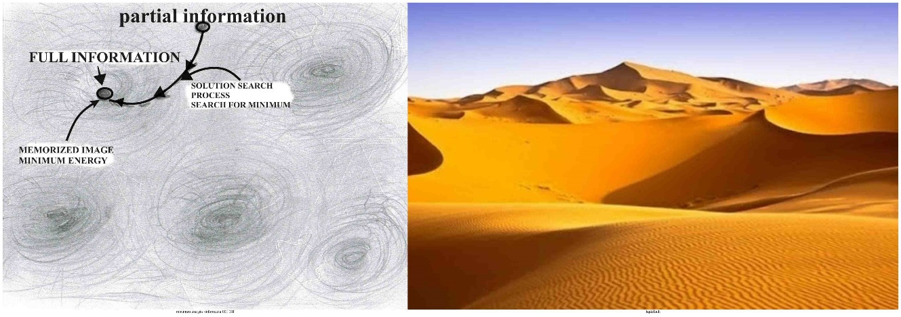
Fig.№8.

Each valley is a kind of attractor, a state to which the system strives if it falls into its area. Information processing is the process in which the system follows the shape of the landscape and seeks minimization of computational energy, i.e. the bottom of a certain valley, similar to the movement of a ball under the action of gravity. With incomplete initial information, where only some of the characteristics of the image are given, the system is able to restore the full image, sliding into the nearest "valley" containing the full information.
Information processing, as a collective calculation, differs significantly from the process of information processing in a classical computer. While in modern computers the “trajectory of calculation” is determined by instructions in steps defined by the software, i.e. the calculation program, in neural networks the strongly connected elements form a specific environment that “focuses the calculation into a single continuous process”. The process proceeds as a relaxation of the system to a state closest to the previously entered image. The memory of the system is in the form of a certain number of “valleys” and changes in the energy landscape. But the essential difference lies in the fact that the interaction of the newly arriving diversity with the already stored information occurs by content, and not by address. Pre-recorded images in memory play a central role in the processes of recognition and classification. As D. Hopfield and D. Tank note, the concept of associative memory comes from psychology and even simple nervous systems have the property of associative memory, therefore it must be a spontaneous property of the neural network.
*7.
Generalization of images and development of prototypes. The «spin-glass» model of associative memory is too coarse and neglects important details compared to the original - the biological neural network.
The first is that it uses the mean field theory (MFT), i.e. the interaction of each neuron with each. It was necessary because under this condition there are analytical solutions from which qualitative conclusions can be drawn. On this occasion Dotsenko writes:
"This spin-glass physics, which is presented here, is not the result of a theoretical conclusion. In a certain sense, it is the result of a "logical leap" from strict theoretical results.... The concept of spin-glass physics can be formulated separately from this model from which it was obtained and in itself, it looks so natural and aesthetically attractive that it would be very strange if something similar did not exist in Nature." ;
A second coarsening is that the analogy of impulse generation or retention in a biological neuron, which corresponds to the orientation of the spin either "up" or "down" ...does not take into account the different types of neurons, their diverse anatomical and functional structure, as well as the multitude of intermediate states, which are obviously not without importance in the biological prototype;
Third, in the central nervous system there are evolutionarily emerged specialized "apparatus" serving associative memory in the form of specialized neural networks, which are responsible for: movements, their accuracy and correction; for the various sensory modalities and the feedback between the center and sensors; emotions and motivation; sleep and wakefulness, attention and activation, etc. and are the subject of study of psychophysiology. The structure and functions of these specialized "apparatus" must also be taken into account in order to obtain a complete picture of the phenomenon.
Despite the strong coarsening, this group of models perfectly describes associative distributed memory, and these are in fact the defining qualities of the psyche, as a system of information. A sufficiently detailed picture of what kind of system the psyche is is presented, and for the psyche with consciousness, further development of these model representations is necessary.
An important property of the model, i.e. this type of memory, is that when a sufficient number of similar images arrive, it is capable of generating a generalized image (or of classifying and generalizing the incoming images!). With an increase in the number of images recorded in memory, it turns out that a certain merging of energy minima occurs. Calculations conducted at the EIM show that with a sufficient number of recorded images, the probability of a general minimum occurring is very high, for example, of the order of 75%, if the number of images is of the order of 0.2 N, where N is the number of neurons.) Prototyping can definitely be considered as an elementary form of generalization, especially since a similar phenomenon is observed in real biological neural networks when processing visual information. In higher mental processes, such as thinking, a similar process corresponds to the formation of a concept. Of course, at this level of coarsening one cannot expect a detailed and complete description of the mental, but models of this type certainly allow for qualitative assessments and carry within themselves that necessary moment of transition from the physical and neurophysiological to the mental.
*8.
In phylogenetic terms, it is of key importance that the system is insensitive (or weakly sensitive) to defects, as well as that it can be expanded and upgraded. As is well known, the brain of higher animals (humans) has evolved, with old brain sections being maintained and upgraded by adding new ones, which in certain cases begin to dominate. This feature of biological neural networks is perfectly connected with the model of associative distributed memory considered here. The distribution of memory is the first condition for adding and successfully coordinating new neural structures with already existing ones. New and old neural networks are coordinated by building a common memory space. The common memory space means that memory “migrates” from old structures to new ones and extends over the entire system. Conversely, when part of the neural networks is removed as a storage medium, the remaining working sections contain all the information for the successful functioning of the psyche.
This feature is extremely important in evolutionary terms and for understanding the process of evolutionary improvement of the nervous system. How does the complex “hardware” of the brain function in sufficiently developed organisms!? It is necessary to take into account that all this “equipment” of new additions of additional neural networks, with new settings and improvements, compared to the initial diffuse nervous system, has one single goal: to provide a better, with more possibilities, space for existence and development of the psyche, as a system of information. From this angle of vision, a “light in the tunnel” appears in the process of understanding the activity of the nervous system. The nervous system evolves and improves in the process of servicing the psyche. A process of creating conditions under which the information system more successfully achieves its functions: adequate management of behavior. The error, set long ago through the attitudes of physicalism as a methodological orientation, of specialists of all types: neurobiologists, physiologists and even cyberneticists, does not allow the correct interpretation of the abundance of analytical research. In the field of anatomy and physiology of the nervous system, there is a mass of knowledge that is being misinterpreted.
It is not neurons and neural structures and brain apparatuses that are the center around which everything should revolve, but memory (and the psyche emerging in it!) is this center!
This is the idea that is slowly but surely making its way. If memory is understood as a system of information and is the determining component in evolutionary selection, this understanding brings much more concreteness and clarity to the interpretation of the multitude of results achieved. It places the task in a new, much more heuristic plane, and not along the vector of crude eliminative materialism. The psyche, as a system of information, cannot be directly “touched”, but it is more important and more material than what can be cut and touched.
Conclusion:
The three models of associative distributed memory considered are a sufficiently reliable basis for building the psyche as a system of information. It is necessary that the results obtained through these models be specifically refined for the interpretation of the empirical characteristics of the psyche and the key issues related to the developed psyche - self-awareness, consciousness, subconscious psyche, emotions and feelings, attention, imagination, thinking, etc. What type of system is the psyche in an ontological plan and what conclusions can be drawn from the answer to this question.
From the point of view of the idea of ​​personal immortality, the focus of attention is on the relationship between the nervous system as a carrier system and the psyche as a system of information. In the concepts of the models considered, of which the “spin-glass” model is the most important, this same relationship can be reformulated. The nervous system is appropriately structured and interacting neural networks in which specific systemic processes occur. These systemic processes lead to the emergence of neurological and later psychic memory. Neurological memory under the influence of sensory flow turns into psychic memory, which is distributed and associative. This is the psyche, as a system of information in its most general definition. The specific content of this self-organizing system of information is of great importance, because it is it that determines the future development of memory, as a specific system.
Each model is a certain coarsening and simplification of reality, which is done with a purpose. Usually the goal is to understand the essence, and not to reproduce all the details and features, which can be done at a later stage of research. This position is especially relevant when clarifying the general framework of the idea of ​​technological personal immortality, i.e. superpreservation in the mesoworld. In order to make certain conclusions in an explicit form, it is necessary to offer new ideas to the most significant problems. These hypotheses do not aim to create a complete private theory of the psyche and its immediate carrier, but to facilitate the understanding of the system-information approach to personal immortality. All three models considered, in essence, have an exceptional contribution to understanding the phenomena related to the relationship between the nervous system and the psyche. The important unclear question, for which this entire study and research was undertaken – the psychophysiological problem (the psychophysical problem!), received a very definite, working materialistic solution. And it is characterized as a fundamental question in posing and analyzing the idea of ​​personal immortality.
Technological personal immortality, both as a theory and as a technology, rests on scientific knowledge and its technical applications. For this idea, the thesis that we know nothing and can do nothing is highly unacceptable. Social practice in the form of medicine, experimental neuroscience and psychology, programming and computational experiment, etc., refutes the extreme forms of this thesis. But it follows the softened and adapted form – we do not know enough! And this ideology is sincerely professed by a huge number of specialists – doctors, neurosurgeons, psychiatrists, ecologists, physicists..., all very busy people whose time is too precious to deal with general issues. Knowledge that is not popular enough or is not in established scientific journals. But it is worth, even in a still controversial and preliminary form, to say something that may be interesting to all of them.
Sources:
- DJ Amit, H Gutfreund, H Sompolinsky , Spin-glass models of neural networks, Physical Review A, 1985,
- Арбиб М., Метафорический мозг, М.,Мир, 1976г., стр.260, Arbib Michael A., The metaphorical brain, 1972.;
- A Barra, G Genovese, F Guerra, How glassy are neural networks?, Journal of Statistical …, 2012,;
- Binder K., Young A.P., Spin glasses: Experimental facts, theoretical concepts, and open questions, Reviews of Modern Physics, vol.58, No. 4, October1986;
- Богатых Б.А., Фрактально-голографический конструкт и теория поля К. Левина, Fractal holographic construct and the field theory of K. Lewin, Институт атомной энергетики Национального исследовательского ядерного университета МИФИ (ИАТЭ НИЯУ МИФИ), г. Обнинск, Obninsk Institute for Nuclear Power Engineering, National Research Nuclear University MEPhI, Obninsk, Russia;
- Брайнес С.Н., Биологическая и медицинская кибернетика,1971г., стр.39, Brynes S.N., Biological and medical cybernetics, 1971, p.39;
- Бернштейн Н.А., Физиология движения и активность, 1990, Bernstein N.A., Physiology movements and activity, 1990 ; http://elib.gnpbu.ru/text/bernshteyn_fiziologiya-dvizheniy_1990/go,0;fs,1/;
- Vedenov A.A., Modeling elements of thinking, Nauka, 1988, p.53.
- Westlake P.R., The Possibilities of Neural Holographic Processes within the Brain, Kybernetik, 7, №4, 1970, p.129 –153;
- L.M. Wekker – "Psychic Processes" vol. 1 (1974.;
- Gorbachevskaya E.N., Krasnov S.S. HISTORY OF THE DEVELOPMENT OF NEURON NETWORKS, Journal of the Volga University named after V.N. Tatishcheva No. 1 (23) 2015.;
- Давыдовская Н.А. ДОМИНАНТА А.А. УХТОМСКОГО И ГОЛОГРАФИЧЕСКАЯ МОДЕЛЬ РАЗУМА , http://raen-noos.narod.ru/plan_3_5.htm ;
- Donald R. J. Franklin and D. J. K. Mewhort Queen’s University, Memory as a Hologram: An Analysis of Learning and Recall, Canadian Journal of Experimental Psychology / Revue canadienne de psychologie expérimentale, 2015 Canadian Psychological Association 2015, Vol. 69, No. 1, 115–135;
- Доценко B.C., ФИЗИКА СПИН-СТЕКОЛЬНОГО СОСТОЯНИЯ, УФН, 1993 г, Том 163, № 6; Dotsenko B.C., PHYSICS OF THE SPIN-GLASS STATE, UFN, 1993, Volume 163, No. 6;
- Eichenbaum H., Still searching for the engram, Learn Behav. 2016 Sep; 44(3): 209–222.;
- Кинцель В., Спиновые стекла как модельные системы для нейронных сетей, УФН, Май, 1987г.,Том 152, вып.1.; Kinzel V., Spin glasses as model systems for neural networks, UFN, May, 1987, Volume 152, Issue 1.
- Кольер Р., Беркхарт К., Лин Л., Оптическая фотография, М. ,Мир, 1973г., стр.457, (оригинал: Robert J. Coller, Christoph B. Burekhardt, Lawrence H. Lin, Optical Holography, 1971, New York and London.;
- И. Я. Коренблит, Ε. Φ. Шендер, СПИНОВЫЕ СТЕКЛА И НЕЭРГОДИЧНОСТЬ, УФН, 1989, т.157, вып.2., I. Ya. Korenblit, E. F. Shender, SPIN GLASSES AND NON-ERGODICITY, Uspekhi Fizika, 1989, vol. 157, issue 2.;
- Колев Т., Личното безсмъртие без мистика и религия, из. "От гледна точка на Вечността", Чирпан, 2011, Kolev T., Personal immortality without mysticism and religion, published by "Sub Specie Aeternitatis", Chirpan, 2011;
- Кремянский В.И., Методологические проблемы системного подхода к информации, изд. Наука, М.,1977г. (V.I. Kremyansky, Methodological problems of the system approach to information, ed. Nauka, M., 1977.);
- Кремянский В.И., Гипотеза о материальных основах осознавания, Проблемы сознания,М.1966. (V.I. Kremyansky, Hypothesis of material foundations of cognition, Problems of cognition, M. 1966.;
- Kohonen T., Associative Memory, A System-Theoretical Approach, Springer, 1978;
- Corliss Lamont, “The Illusion of Immortality”, 1935, The Fundamental Issue,;
- Lashley K.S. ,"Studies of Cerebral Function in Learning", Journal of Comparative Neurology vol. 79. 1943 ; "In search of the engram." Society of Experimental Biology Symposium 4: 454–482. 1950.;
- Mezard Μ., Parisi G., VirasoroM. Spin Glass Theory and Веyond. — World Scientific, 1988.— Pp. 476.;
- Milner P.M., Physiological Psyhology, 1970,;
- Nichimori H., Statistical Physics of Spin-Glasses and Information Prossesig, Tokyo – Oxford, 2001;
- Петров Сава, Методология на субстратния подход,С., Наука и изкуство, 1980г., стр.230, (Petrov Sava, Methodology of the Substrate Approach, S., Science and Art, 1980, p.230.);
- Pribram K. , Languages of the Brain,1971 ,( Прибрам К., Языки мозга, 1975г.);
- Takaaki Musha, Holographic View of the Brain Memory Mechanism Based on Evanescent Superluminal Photons, 17 August 2012.
- Rammal R, Toulouse G.,Virasoro M.A., Ultrametricity for physicists, Reviews of Modern Physics, Vol.58,No3,1986.;
- Саган К., Драконы эдема, М.,1986г., стр.63. Carl Sagan, The Dragons of Eden, 1977.;
- D.W. Tank, J.J. Hopfield COLLECTIVE COMPUTATIONS IN NEURO-LIKE ELECTRONIC CIRCUITS, "In the world of science" (Scientific American) 1988. p. 44;
- Хакен Г., Лазерная светодинамика, М., Мир, 1988г., ( Haken H., Laser Light Dyhamics, 1985, Light, v.2 );
- Khomskaya E.D., Brain and activation, Moscow State University, 1972;
- Hopfied J.J., Neural Networks and Physical Systems with Emergent Collective Computational Abilities, Proc. Natl. Acad. Sci. USA, vol.79. pp.2354 – 2358, April,1982;
- https://www.nobelprize.org/prizes/lists/all-nobel-prizes-in-physics/
- Чугай А.А., ГОЛОГРАММНАЯ ТЕОРИЯ БИОЛОГИЧЕСКОЙ ПАМЯТИ, Днепропетровский гуманитарный университет,2015г.; Chugai A.A., THE HOLOGRAM THEORY OF BIOLOGICAL MEMORY, Dnipropetrovsk Humanities University, 2015.

Lashley K.S. ,"Studies of Cerebral Function in Learning", Journal of Comparative Neurology vol. 79. 1943 ; "In search of the engram." Society of Experimental Biology Symposium 4: 454–482. 1950.
Eichenbaum H., Still searching for the engram, Learn Behav. 2016 Sep; 44(3): 209–222.
Кремянский В.И., Методологические проблемы системного подхода к информации, изд. Наука, М.,1977г. (V.I. Kremyansky, Methodological problems of the system approach to information, ed. Nauka, M., 1977.)
Кремянский В.И., Гипотеза о материальных основах осознавания, Проблемы сознания,М.1966. (V.I. Kremyansky, Hypothesis of material foundations of cognition, Problems of cognition, M. 1966.
Колев Т., Личното безсмъртие без мистика и религия, из. "От гледна точка на Вечността", Чирпан, 2011, Kolev T., Personal immortality without mysticism and religion, published by "Sub Specie Aeternitatis", Chirpan, 2011;
Петров Сава, Методология на субстратния подход,С., Наука и изкуство, 1980г., стр.230, (Petrov Sava, Methodology of the Substrate Approach, S., Science and Art, 1980, p.230.)
Westlake P.R., The Possibilities of Neural Holographic Processes within the Brain, Kybernetik, 7, №4, 1970, p.129 –153.; Pribram K. , Languages of the Brain,1971 ,( Прибрам К., Языки мозга, 1975г.); Брайнес С.Н., Биологическая и медицинская кибернетика,1971г., стр.39 –119. и др.; Kohonen T., Associative Memory, A System-Theoretical Approach, Springer, 1978.
Арбиб М., Метафорический мозг, М.,Мир, 1976г., стр.260, Arbib Michael A., The metaphorical brain, 1972.
Кохонен Т., „Асоциативная память“, (руски превод), Мир, 1980, стр.34. (Kohonen T., Associative Memory, A System-Theoretical Approach, Springer, 1978)
Давыдовская Н.А. ДОМИНАНТА А.А. УХТОМСКОГО И ГОЛОГРАФИЧЕСКАЯ МОДЕЛЬ РАЗУМА , http://raen-noos.narod.ru/plan_3_5.htm , Богатых Б.А., Фрактально-голографический конструкт и теория поля К. Левина, Fractal holographic construct and the field theory of K. Lewin, Институт атомной энергетики Национального исследовательского ядерного университета МИФИ (ИАТЭ НИЯУ МИФИ), г. Обнинск, Obninsk Institute for Nuclear Power Engineering, National Research Nuclear University MEPhI, Obninsk, Russia; Чугай А.А., ГОЛОГРАММНАЯ ТЕОРИЯ БИОЛОГИЧЕСКОЙ ПАМЯТИ, Днепропетровский гуманитарный университет,2015г.; Takaaki Musha, Holographic View of the Brain Memory Mechanism Based on Evanescent Superluminal Photons, 17 August 2012; Donald R. J. Franklin and D. J. K. Mewhort Queen’s University, Memory as a Hologram: An Analysis of Learning and Recall, Canadian Journal of Experimental Psychology / Revue canadienne de psychologie expérimentale, 2015 Canadian Psychological Association 2015, Vol. 69, No. 1, 115–135 и др.
Хакен Г., Лазерная светодинамика, М., Мир, 1988г., ( Haken H., Laser Light Dyhamics, 1985, Light, v.2 )
Виж: Кольер Р., Беркхарт К., Лин Л., Оптическая фотография, М. ,Мир, 1973г., стр.457, (оригинал: Robert J. Coller, Christoph B. Burekhardt, Lawrence H. Lin, Optical Holography, 1971, New York and London.)
In holography, this thinner matter is the interference pattern, which later serves as a diffraction grating and forms the wave during reproduction.
And not just DNA molecules!
Kohonen T., Associative Memory, A System-Theoretical Approach, Springer, 1978.
Kohonen's scheme can be presented in the following way: Kohonen's scheme is ideally consistent with the concept introduced later by Hopfield - collective associative computation.
The connection with the insights of V.I. Kremyansky is obvious: "there are two simple forms of correlation of processes that fully satisfy both immediacy and synchronicity - these are circular and vortex movements.
Binder K., Young A.P., Spin glasses: Experimental facts, theoretical concepts, and open questions, Reviews of Modern Physics, vol.58, No. 4, October1986; Кинцель В., Спиновые стекла как модельные системы для нейронных сетей, УФН, Май, 1987г.,Том 152, вып.1.; Rammal R, Toulouse G.,Virasoro M.A., Ultrametricity for physicists, Reviews of Modern Physics, Vol.58,No3,1986.; Hopfied J.J., Neural Networks and Physical Systems with Emergent Collective Computational Abilities, Proc. Natl. Acad. Sci. USA, vol.79. pp.2354 – 2358, April,1982.]; DJ Amit, H Gutfreund, H Sompolinsky , Spin-glass models of neural networks, Physical Review A, 1985, Mezard Μ., Parisi G., VirasoroM. Spin Glass Theory and Веyond. — World Scientific, 1988.— Pp. 476.; Доценко B.C., ФИЗИКА СПИН-СТЕКОЛЬНОГО СОСТОЯНИЯ, УФН, 1993 г, Том 163, № 6; Nichimori H., Statistical Physics of Spin-Glasses and Information Prossesig, Tokyo – Oxford, 2001; A Barra, G Genovese, F Guerra, How glassy are neural networks?, Journal of Statistical …, 2012, и др.
Кинцель В., Спиновые стекла как модельные системы для нейронных сетей, УФН, Май, 1987г.,Том 152, вып.1.; Mezard M.,Parisi G., Virasoro M., Spin Glass theory and Beyond, World Scientific Lecture in Physics – Vol.9, 1987, 2004.
Frustration comes from the English word frustration, literally translated as "fraud of hopes". The term was introduced by G. Toulouse in 1977.
И. Я. Коренблит, Ε. Φ. Шендер, СПИНОВЫЕ СТЕКЛА И НЕЭРГОДИЧНОСТЬ, УФН, 1989, т.157, вып.2. Образците имат история и средните стойности на величините по време и по пространство не съвпадат. I. Ya. Korenblit, E. F. Shender, SPIN GLASSES AND NON-ERGODICITY, Uspekhi Fizika, 1989, vol. 157, issue 2. The samples have a history and the average values ​​of the quantities in time and space do not coincide.
The number is astronomical and is determined by the number of atoms and the frustrated bonds between them.
Dotsenko B.S. PHYSICS OF SPIN-GLASTIC STATES, UFS, 1993, Vol. 163, No. 6., p.5.
This is the place to remember how necessary this phase transition was in the holographic model, and in holography it is introduced from outside by laser radiation.
Rammal R, Toulouse G, VirasoroM.A., Rev. Mod. Phys., 58, 765 (1986) – a detailed overview of the topic! All triangles in the state space are either equilateral d (1,2) = = d (1,3) = d (2,3P), or isosceles with a base smaller than the hip d (1,2) = d (1,3) > d (2,3). The triangle rule was established by studying the distribution function Ρ (g1( q2 , qs ), the probability of finding three overlapping valleys.
Hopfied J.J., Neural Networks and Physical Systems with Emergent Collective Computational Abilities, Proc. Natl. Acad. Sci. USA, vol.79. pp.2354 – 2358, April,1982.
https://www.nobelprize.org/prizes/lists/all-nobel-prizes-in-physics/
Gorbachevskaya E.N., Krasnov S.S. HISTORY OF THE DEVELOPMENT OF NEURON NETWORKS, Journal of the Volga University named after V.N. Tatishcheva No. 1 (23) 2015
D.W. Tank, J.J. Hopfield COLLECTIVE COMPUTATIONS IN NEURO-LIKE ELECTRONIC CIRCUITS, "In the world of science" (Scientific American) 1988. p. 44.
Dotsenko V.S., Physics of the spin-glass state, UFN, 1993, Volume 163, No. 6, p.2
Бернштейн Н.А., Физиология движения и активность, 1990, Bernstein N.A., Physiology movements and activity, 1990 ; http://elib.gnpbu.ru/text/bernshteyn_fiziologiya-dvizheniy_1990/go,0;fs,1/
Milner P.M., Physiological Psyhology, 1970, Khomskaya E.D., Brain and activation, Moscow State University, 1972; etc.
Vedenov A.A., Modeling elements of thinking, Nauka, 1988, p.53.
Саган К., Драконы эдема, М.,1986г., стр.63. Carl Sagan, The Dragons of Eden, 1977.
It is necessary to decode and extract information from the immediately supporting neurodynamic systems.
L.M. Wekker – "Psychic Processes" vol. 1 (1974);
Corliss Lamont, “The Illusion of Immortality”, 1935, The Fundamental Issue, p.32.

